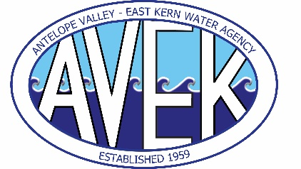
ANTELOPE VALLEY-EAST KERN WATER AGENCY
ANTELOPE VALLEY-EAST KERN WATER AGENCY FINANCING AUTHORITY
6450 WEST AVENUE “N”
PALMDALE, CA 93551

January 6, 2026

NOTICE OF CANCELLATION OF TWO (2)
REGULAR FINANCE COMMITTEE MEETINGS
AND SCHEDULE OF TWO (2) SPECIAL FINANCE COMMITTEE MEETINGS

Notice is hereby provided that the two (2) Regular Meetings of the Finance Committee of the Antelope Valley-East Kern Water Agency and the Antelope Valley-East Kern Water Agency Financing Authority scheduled for 9:00 a.m. on Thursday, January 1, 2026, and Thursday, January 15, 2026, have both been cancelled.

Two (2) Special Finance Committee Meetings will be held in January 2026, at the Agency headquarters located at 6450 West Avenue N, Palmdale, CA 93551, as follows:

Wednesday, January 7, 2026, at 9:00 a.m.; and

Wednesday, January 21, 2026, at 9:00 a.m.

Holly H. Hughes
Board Secretary-Treasurer of the Board of Directors

Posted: January 6, 2026, at 9 am by Holly Hughes, Board Secretary-Treasurer

